Project Report :

Background:

The project focused on improving the structure of a database initially stored in a single table, **"university_professor"**, which included professors' details, universities, organizations, and affiliations. This single table caused redundancy, inefficiency, and difficulty in managing data. To solve this, the data was split into four related tables: **Professors** (personal details), **Universities** (university info), **Organizations** (organization details), and **Affiliations** (linking professors to organizations with their roles). This approach reduced redundancy, improved data consistency, made queries easier, and ensured the database could handle growth efficiently.

Goal:

The main goal of this project is to analyze, manipulate, and efficiently retrieve data by organizing it into a well-structured database.

Method of use :

This system is for administrators, university staff, professors, and organizations to manage and view relevant data.

E-R diagram:

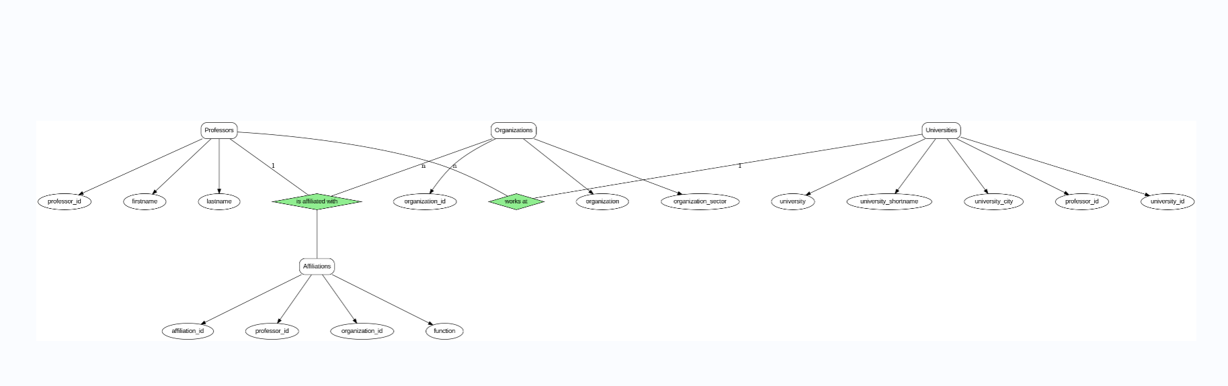

University_id

**Table Design (Schema):**

select *

from university_professor;

CREATE TABLE professors (

professor_id SERIAL PRIMARY KEY ,

firstname VARCHAR(255),

lastname VARCHAR(255)

);

CREATE TABLE universities (

university_id SERIAL PRIMARY KEY,

university VARCHAR(255),

university_shortname VARCHAR(50),

university_city VARCHAR(255),

professor_id INT REFERENCES professors( professor_id)

);

CREATE TABLE organizations (

organization_id SERIAL PRIMARY KEY,

organization VARCHAR(255),

organization_sector VARCHAR(255)

);

CREATE TABLE affiliations (

affiliation_id SERIAL PRIMARY KEY,

professor_id INT REFERENCES professors (professor_id),

organization_id INT REFERENCES organizations(organization_id),

function VARCHAR (255)

);

INSERT INTO professors ( firstname, lastname )

SELECT DISTINCT firstname, lastname

FROM university_professor;

INSERT INTO universities ( university , university_shortname, university_city )

SELECT DISTINCT university, university_shortname, university_city

FROM university_professor;

INSERT INTO organizations (organization, organization_sector)

SELECT DISTINCT organization, organization_sector

FROM university_professor;

INSERT INTO affiliations (professor_id, organization_id, function)

SELECT

p.professor_id,

o.organization_id,

mt.function

FROM university_professor mt

JOIN professors p

ON mt.firstname = p.firstname AND mt.lastname = p.lastname

JOIN organizations o

ON mt.organization = o.organization AND mt.organization_sector = o.organization_sector;

ALTER TABLE university_professor

RENAME TO university_professors;

ALTER TABLE universities

DROP CONSTRAINT universities_professor_id_fkey;

ALTER TABLE universities

DROP COLUMN professor_id ;

ALTER TABLE professors

ADD COLUMN university_id INTEGER;

ALTER TABLE professors

ADD CONSTRAINT fk_university FOREIGN KEY (university_id) REFERENCES universities (university_id);

ALTER TABLE professors

ALTER COLUMN firstname SET NOT NULL,

ALTER COLUMN lastname SET NOT NULL ;

ALTER TABLE universities

ALTER COLUMN university SET NOT NULL,

ALTER COLUMN university_shortname SET NOT NULL,

ALTER COLUMN university_city SET NOT NULL;

ALTER TABLE organizations

ALTER COLUMN organization SET NOT NULL,

ALTER COLUMN organization_sector SET NOT NULL ;

ALTER TABLE affiliations

ALTER COLUMN professor_id SET NOT NULL,

ALTER COLUMN organization_id SET NOT NULL ;

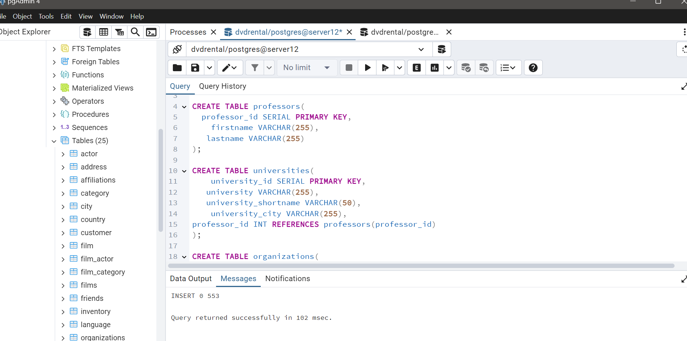

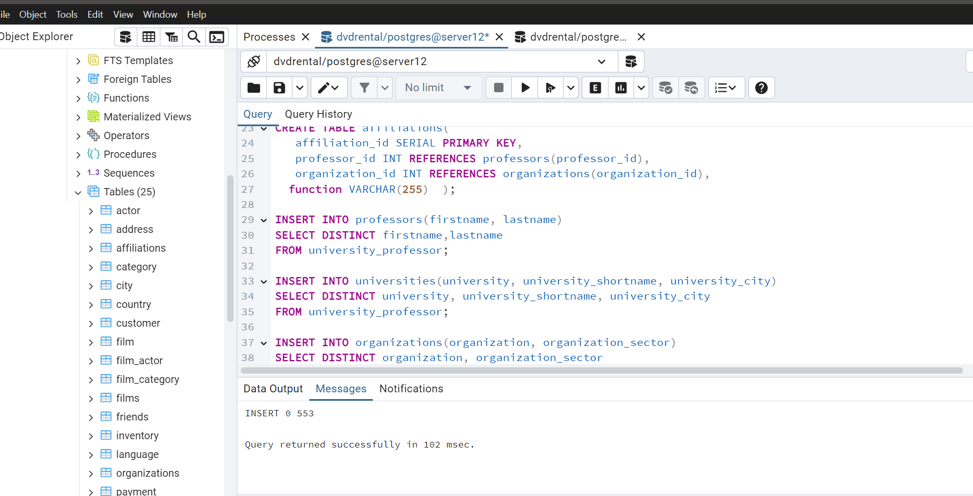

**Example Queries and the outputs:**

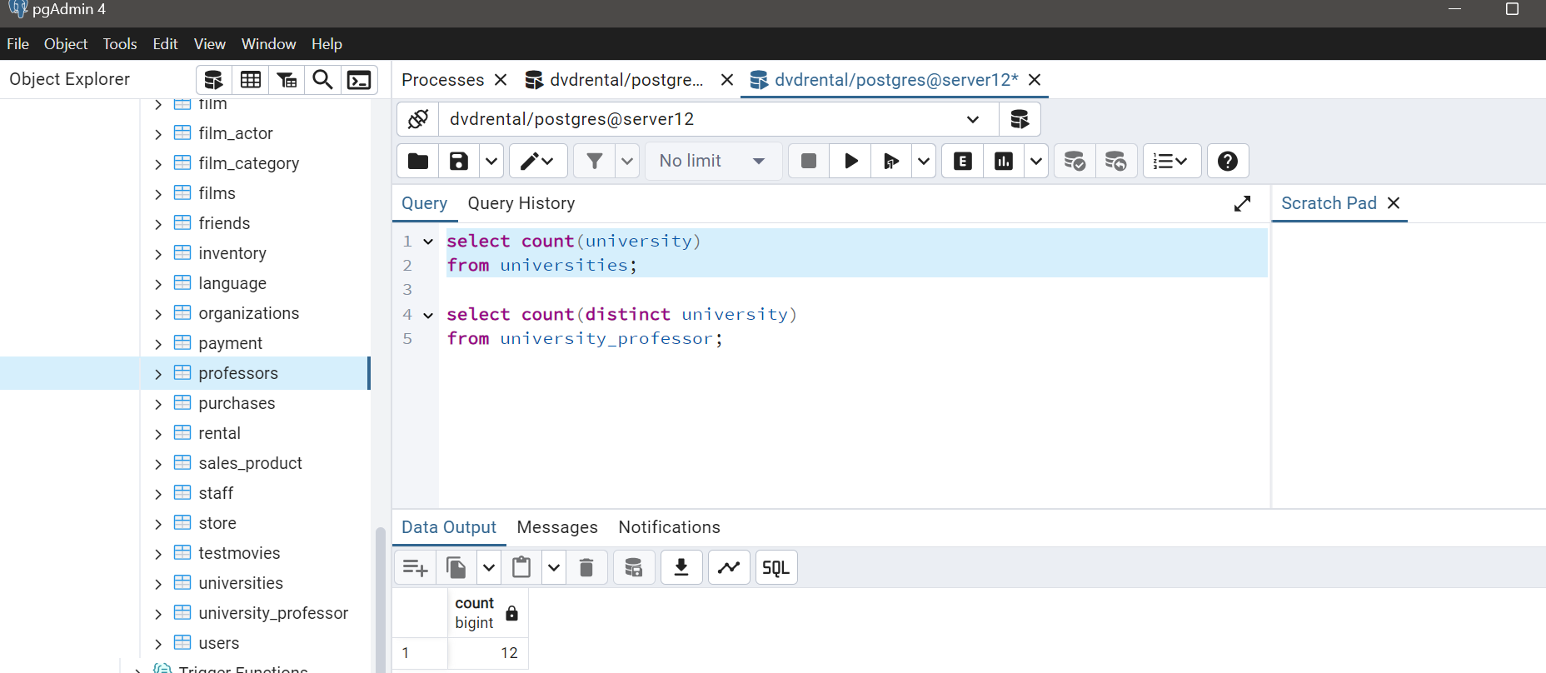

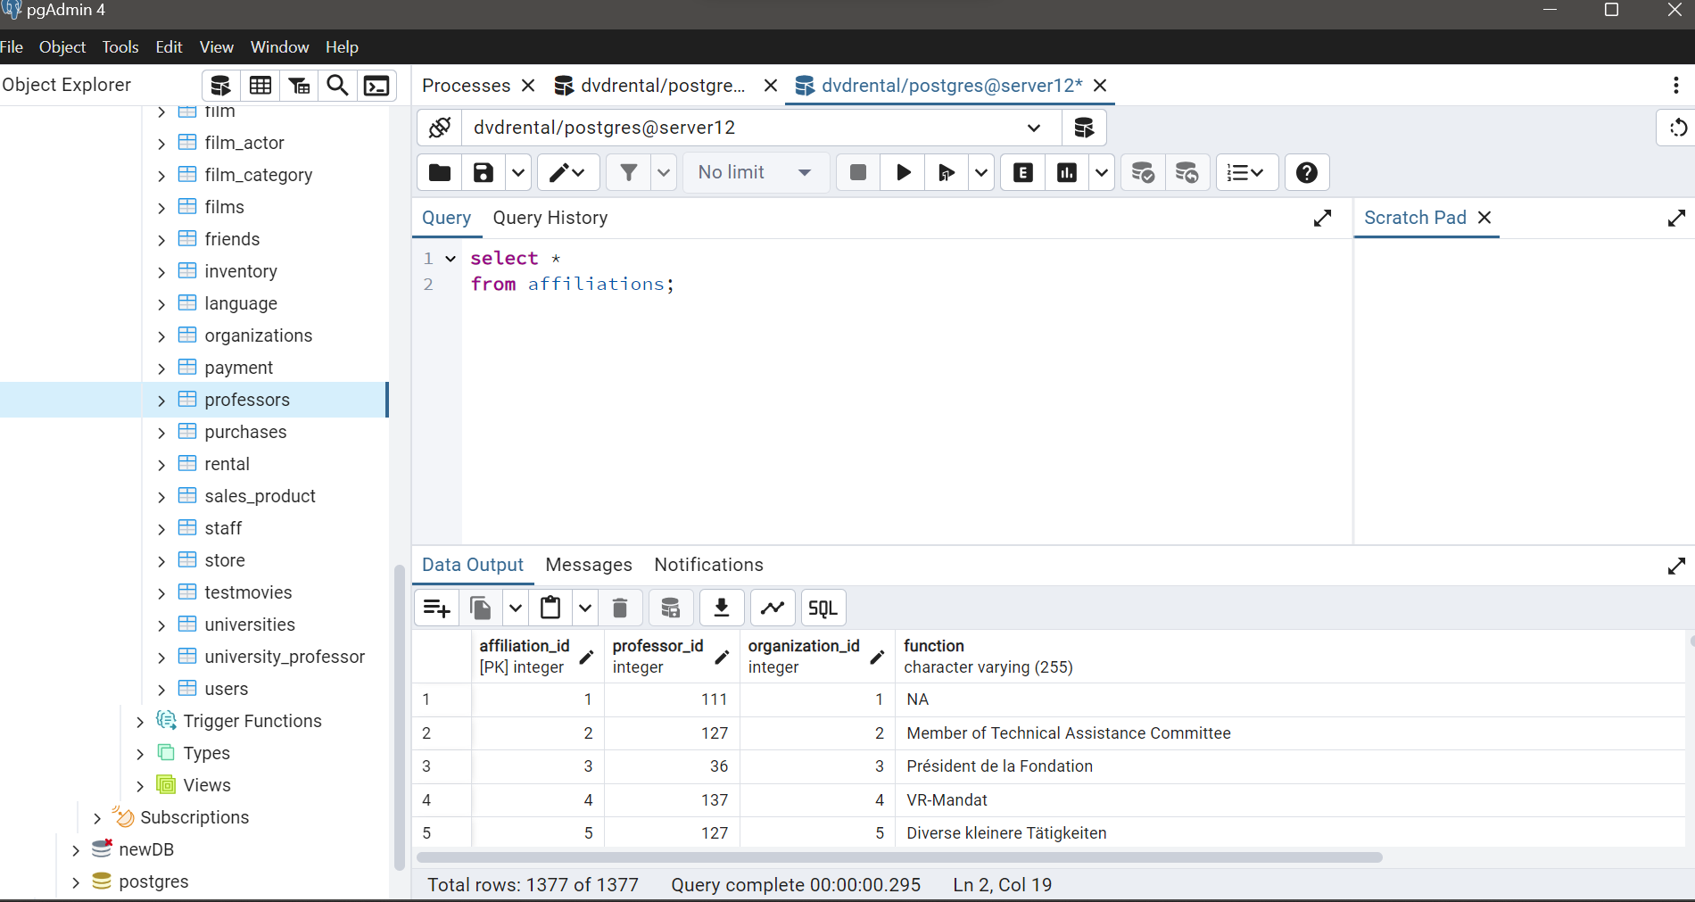

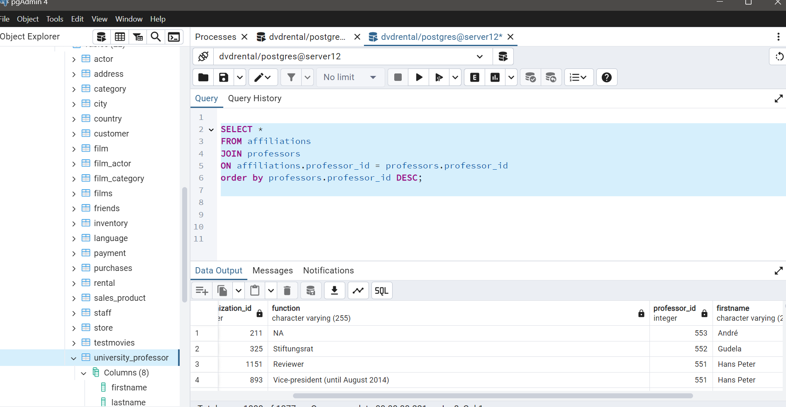

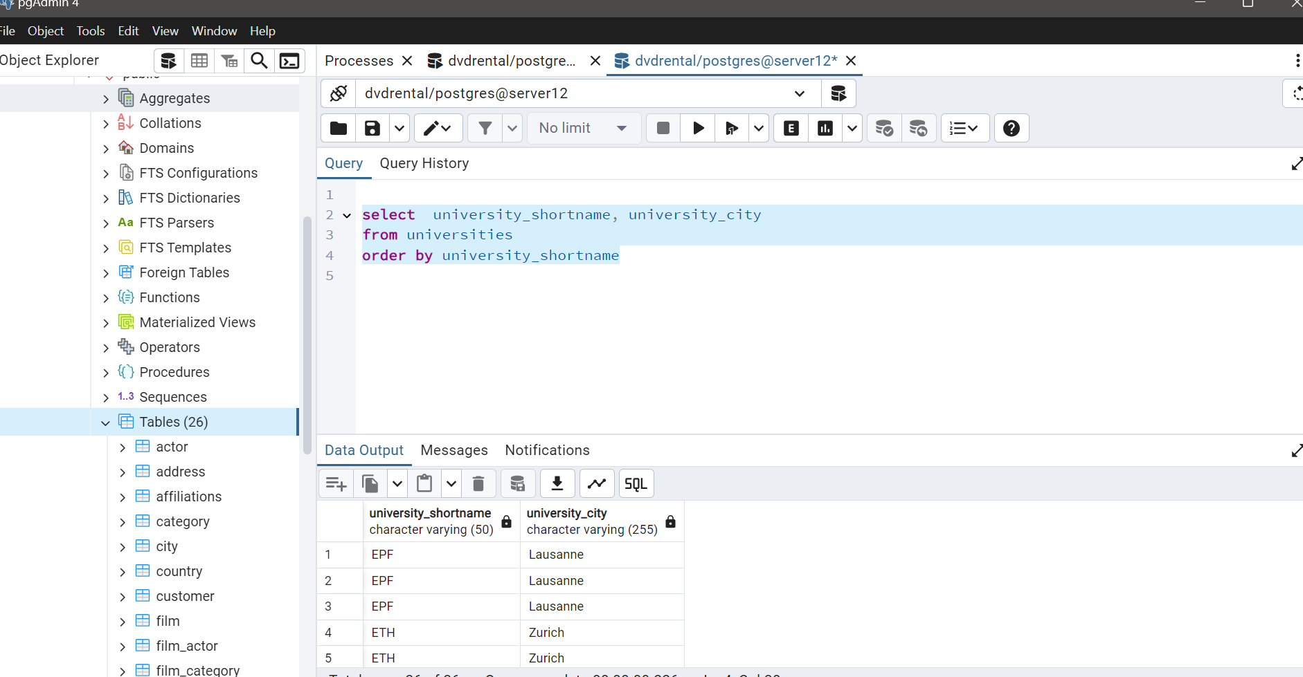

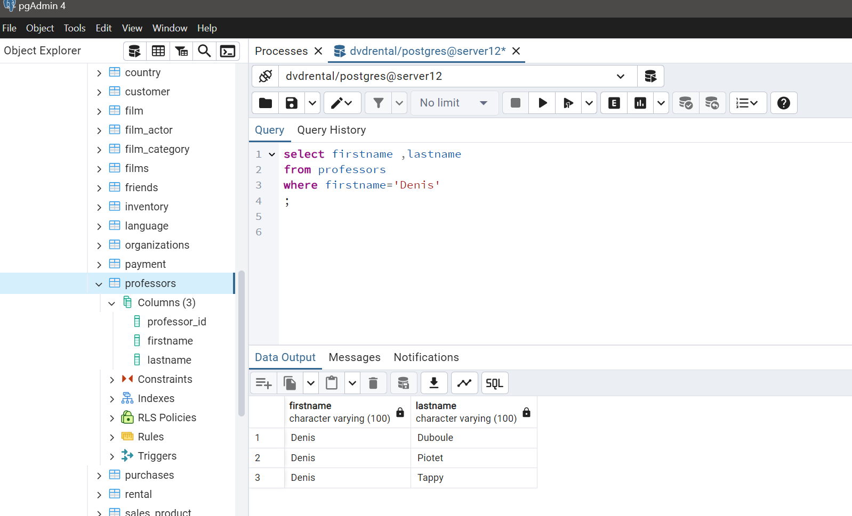

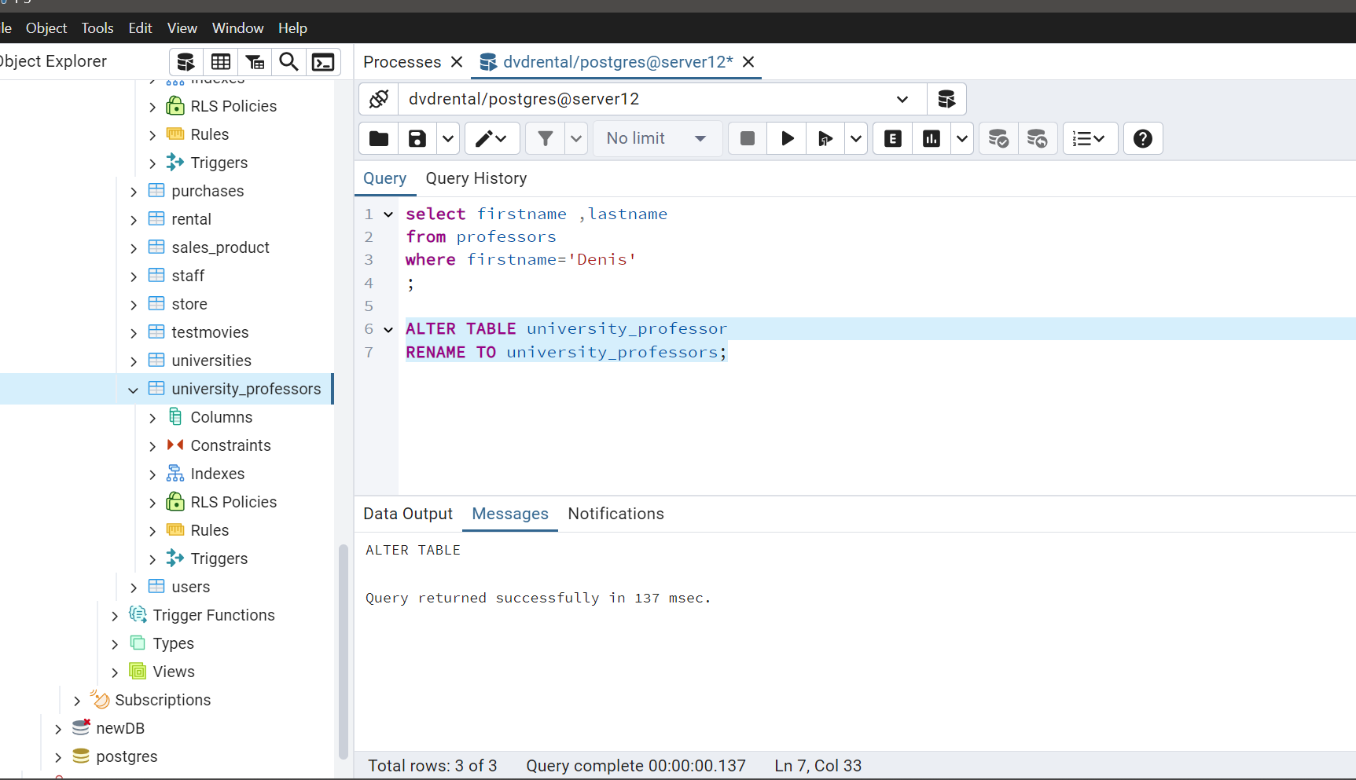

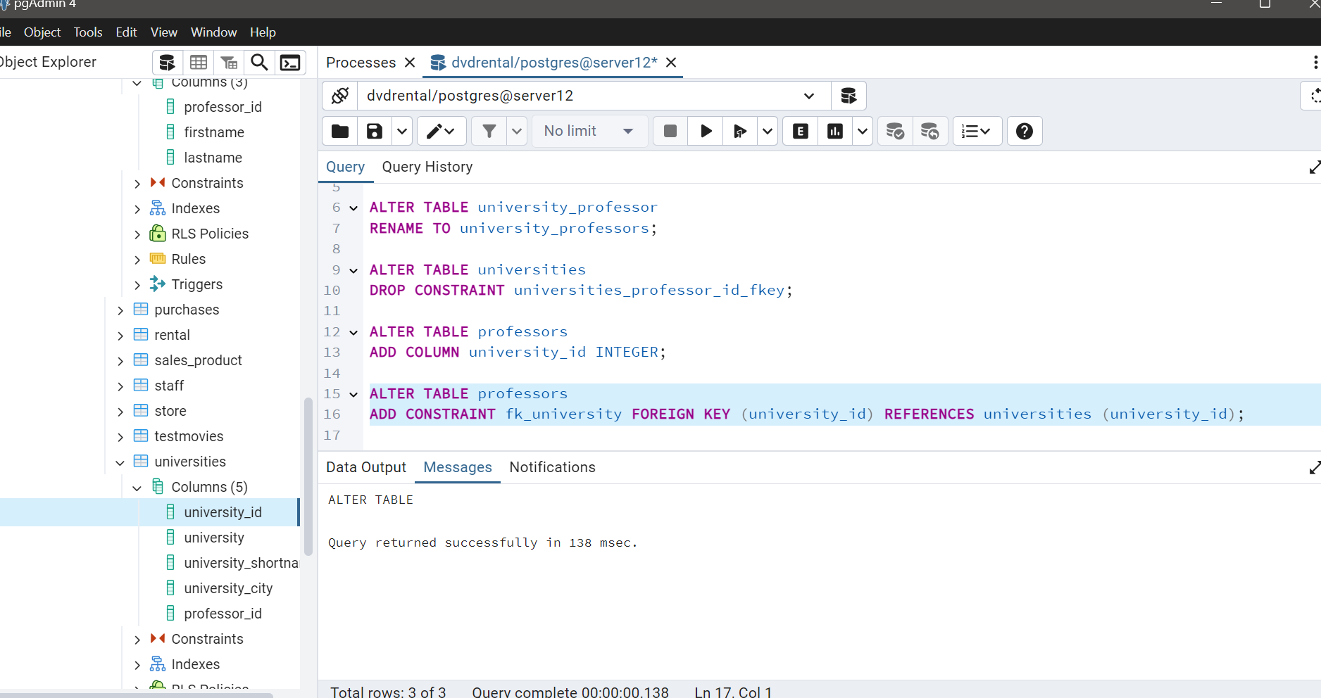

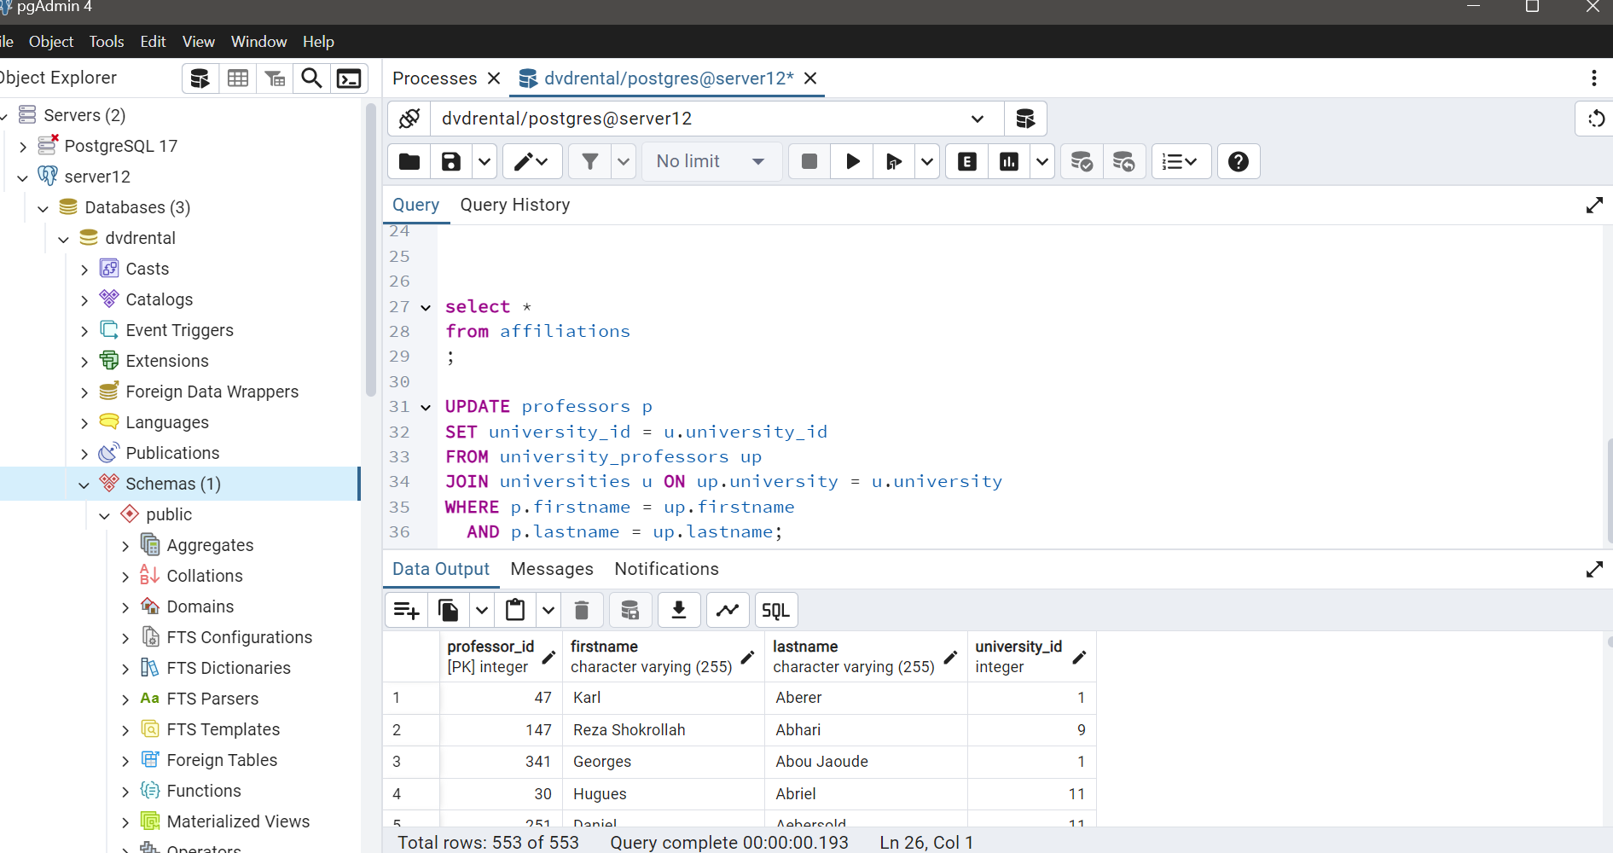

GITHUB LINK: